Effort & Cost Metrics

🔹 Definition
# Source: AI Source: Provided by: [Data Path: Persons Table -> ID Column: 1, Name_En Column: Motasem Essam] -> From: [Chatgpt (GPT‑5 Mini)] on [8/24/2025]
Effort & Cost Metrics are measurements that track the time, resources, and money spent on software testing activities.
They help in estimating, planning, monitoring, and controlling the testing process, ensuring that projects stay within budget and on schedule.
👉 They answer:
- How much effort (time/resources) is being spent on testing?
- How much is the actual testing cost vs. estimated cost?
- Are we efficient in resource utilization?

🛠️ Key Effort & Cost Metrics

1. Test Effort (Person-Hours/Person-Days)
# Source: AI Source: Provided by: [Data Path: Persons Table -> ID Column: 1, Name_En Column: Motasem Essam] -> From: [Chatgpt (GPT‑5 Mini)] on [8/24/2025]
- What: The actual time spent by testers on various testing activities (design, execution, reporting, defect management).
- Formula:
Total Effort=∑(Hours Spent by Each Tester)\text{Total Effort} = \sum (\text{Hours Spent by Each Tester})
- Example: 5 testers × 40 hrs = 200 tester-hours.

2. Planned vs. Actual Effort
# Source: AI Source: Provided by: [Data Path: Persons Table -> ID Column: 1, Name_En Column: Motasem Essam] -> From: [Chatgpt (GPT‑5 Mini)] on [8/24/2025]
- What: Comparison between the estimated effort and the actual effort spent.
- Formula:
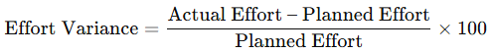
Effort Variance=Actual Effort – Planned EffortPlanned Effort×100\text{Effort Variance} = \frac{\text{Actual Effort – Planned Effort}}{\text{Planned Effort}} \times 100
- Example: Planned = 100 hrs, Actual = 120 hrs → Variance = +20%.

3. Cost per Test Case
# Source: AI Source: Provided by: [Data Path: Persons Table -> ID Column: 1, Name_En Column: Motasem Essam] -> From: [Chatgpt (GPT‑5 Mini)] on [8/24/2025]
- What: Average cost of designing and executing a single test case.
- Formula:
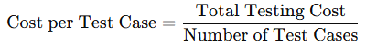
Cost per Test Case=Total Testing CostNumber of Test Cases\text{Cost per Test Case} = \frac{\text{Total Testing Cost}}{\text{Number of Test Cases}}
- Example: $10,000 testing cost / 500 test cases = $20/test case.

4. Cost per Defect
# Source: AI Source: Provided by: [Data Path: Persons Table -> ID Column: 1, Name_En Column: Motasem Essam] -> From: [Chatgpt (GPT‑5 Mini)] on [8/24/2025]
- What: Average cost of finding and fixing a defect.
- Formula:
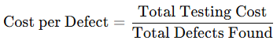
Cost per Defect=Total Testing CostTotal Defects Found\text{Cost per Defect} = \frac{\text{Total Testing Cost}}{\text{Total Defects Found}}
- Example: $12,000 cost / 120 defects = $100/defect.

5. Test Budget Variance
# Source: AI Source: Provided by: [Data Path: Persons Table -> ID Column: 1, Name_En Column: Motasem Essam] -> From: [Chatgpt (GPT‑5 Mini)] on [8/24/2025]
- What: Measures how much actual testing cost deviates from the budget.
- Formula:
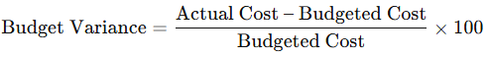
Budget Variance=Actual Cost – Budgeted CostBudgeted Cost×100\text{Budget Variance} = \frac{\text{Actual Cost – Budgeted Cost}}{\text{Budgeted Cost}} \times 100

6. Percentage of Project Cost for Testing
# Source: AI Source: Provided by: [Data Path: Persons Table -> ID Column: 1, Name_En Column: Motasem Essam] -> From: [Chatgpt (GPT‑5 Mini)] on [8/24/2025]
- What: Portion of the overall software project cost spent on testing.
- Formula:
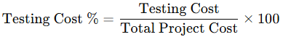
Testing Cost %=Testing CostTotal Project Cost×100\text{Testing Cost \%} = \frac{\text{Testing Cost}}{\text{Total Project Cost}} \times 100
- Example: Testing = $50,000, Project = $500,000 → 10% testing cost.

7. Effort Distribution
# Source: AI Source: Provided by: [Data Path: Persons Table -> ID Column: 1, Name_En Column: Motasem Essam] -> From: [Chatgpt (GPT‑5 Mini)] on [8/24/2025]
- What: How testing effort is distributed across phases.
- Example:
  - Test Planning → 15%
  - Test Design → 25%
  - Test Execution → 40%
  - Defect Management → 20%

📌 Why Effort & Cost Metrics Are Important
# Source: AI Source: Provided by: [Data Path: Persons Table -> ID Column: 1, Name_En Column: Motasem Essam] -> From: [Chatgpt (GPT‑5 Mini)] on [8/24/2025]
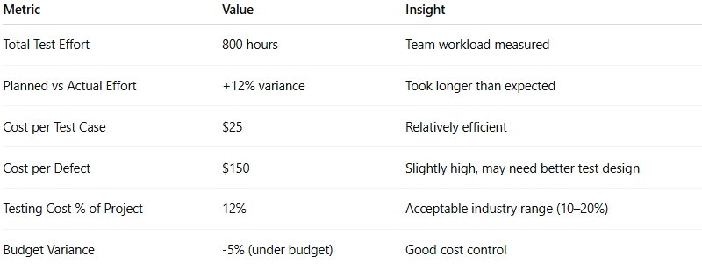
✔ Help with project planning & estimation (predict budget/time).
✔ Provide visibility to stakeholders on testing investment.
✔ Enable cost control and efficiency improvements.
✔ Allow comparison of ROI (Return on Investment) for testing.
✔ Support process optimization by identifying areas with high cost or wasted effort.

✅ Example (Mobile Banking App Project)
# Source: AI Source: Provided by: [Data Path: Persons Table -> ID Column: 1, Name_En Column: Motasem Essam] -> From: [Chatgpt (GPT‑5 Mini)] on [8/24/2025]
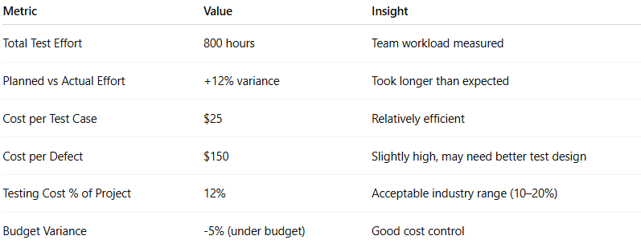
Metric | Value | Insight
Total Test Effort | 800 hours | Team workload measured
Planned vs Actual Effort | +12% variance | Took longer than expected
Cost per Test Case | $25 | Relatively efficient
Cost per Defect | $150 | Slightly high, may need better test design
Testing Cost % of Project | 12% | Acceptable industry range (10–20%)
Budget Variance | -5% (under budget) | Good cost control

👉 In short:
Effort & Cost Metrics help managers understand how much time and money testing consumes, measure efficiency, and ensure that testing provides value within project constraints.

